This document provides instruction on how people with registration/scheduling access in Epic can link visits/visit encounters to research studies

The Visit encounter can be linked when the visit is scheduled, during check in, or at anytime before the visit encounter is completed/closed.
**Note the patient must already be linked to the study prior to check in
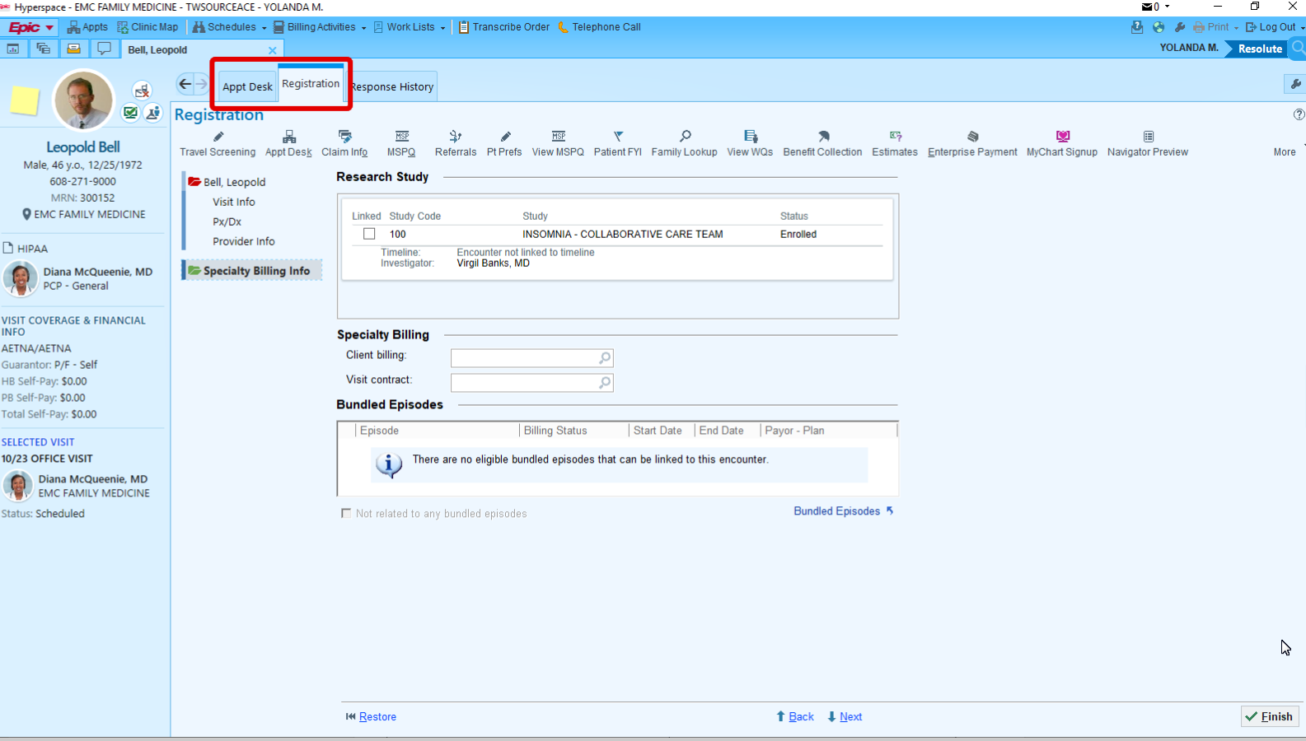
When a patient is linked to the study, the study will show on most registration workflows. You will find it by the “Specialty Billing “section.

**Note Leave Specialty billing fields blank when linking visit to Research Study.
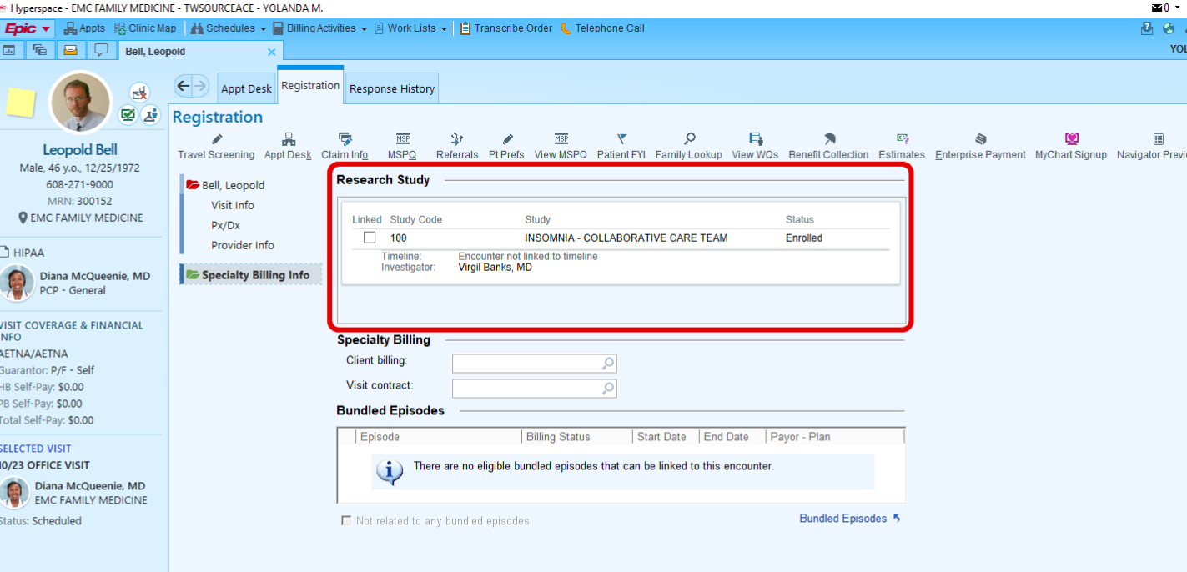
Click the box by the research study

The study title will auto populate into the “Protocol” field
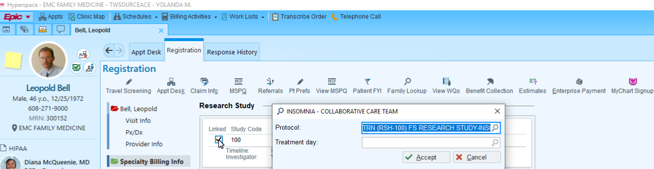
Click on “Accept”

After Clicking on “Accept” the study is now linked and the scheduler would proceed as appropriate.

